**Quantitative Literacy Assignment**

This assignment is a part of our data collection process for our Quality Enhancement Plan, which focuses on Problem Solving through Quantitative Literacy. The assignment does not count as a grade in this course, and does not have bearing on your standing here at Mountain Empire Community College. However, we ask that you please take your time and do your best on this assignment. If you have already completed this assignment in another class, you do not have to do it again.

* You may use a calculator on this assignment.
* Please use the bar graph below to answer the six questions.

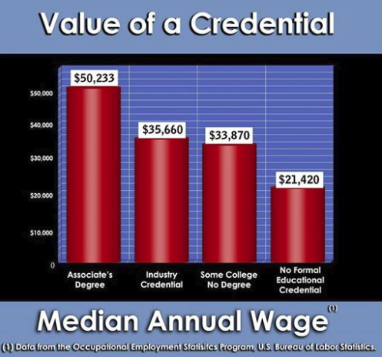

**Interpretation:**

1. What is the above bar graph saying about the importance of an associate’s degree?

_____________________________________________________________________________________

_____________________________________________________________________________________

_____________________________________________________________________________________

**Calculation:**

1. Supposing that the average number of years worked until retirement is 30, how much more would someone with an associate’s degree make than someone who had some college but no degree over the course of their working career?

_____________________________________________________________________________________

_____________________________________________________________________________________

**Representation:**

1. In the space below, create table representing the lifetime earnings (supposing they each worked 30 years) of someone who earned an associate’s degree, someone who earned an industry credential, someone who has some college but no degree, and someone who has no formal education credential. (The first row has been filled in for you.)

|  |  |
| --- | --- |
| **Credential Type** | **Lifetime Earnings** |
| Associate’s degree | $1,506,990.00 |
|  |  |
|  |  |
|  |  |

**Application/Analysis:**

1. What advice would you give to someone who is considering furthering their education with an associate’s degree?

_____________________________________________________________________________________

_____________________________________________________________________________________

_____________________________________________________________________________________

**Assumptions:**

1. Why do you think that someone who has completed an associate’s degree would make so much more over the course of a lifetime?

_____________________________________________________________________________________

_____________________________________________________________________________________

_____________________________________________________________________________________

**Communication:**

1. Based on your responses to questions 1-5, create a 5-6 sentence compelling argument for why someone should complete an associate’s degree.

_____________________________________________________________________________________

_____________________________________________________________________________________

_____________________________________________________________________________________

_____________________________________________________________________________________

_____________________________________________________________________________________

_____________________________________________________________________________________

_____________________________________________________________________________________

_____________________________________________________________________________________

_____________________________________________________________________________________