C & H Law, LLC
111 East First Street
Wise, Va 24283

Request for Proposal;

Our law firm is requesting bids on a complete IT solution for our law offices located in Wise and Big Stone Gap Virginia. We are currently conducting our business in the traditional “paper-full” office manner and we would like to progress to the current “paper-less” office model. We are looking for a company/individual to design, install, configure, and maintain a LAN environment at each of our two locations and also provide WAN connectivity between the two sites. Bids for this RFP will be accepted from 04/26/21 till 05/07/21. The various solutions will then be evaluated and the best overall solution meeting our needs will be accepted. Documents detailing our needs, current equipment, security concerns, office layout, and service requirements are attached to this brief synopsis. Please direct any questions that you may have for further information to Fred R. Coeburn (fcoeburn@mecc.edu).

Dewey Cheetum
President & CEO
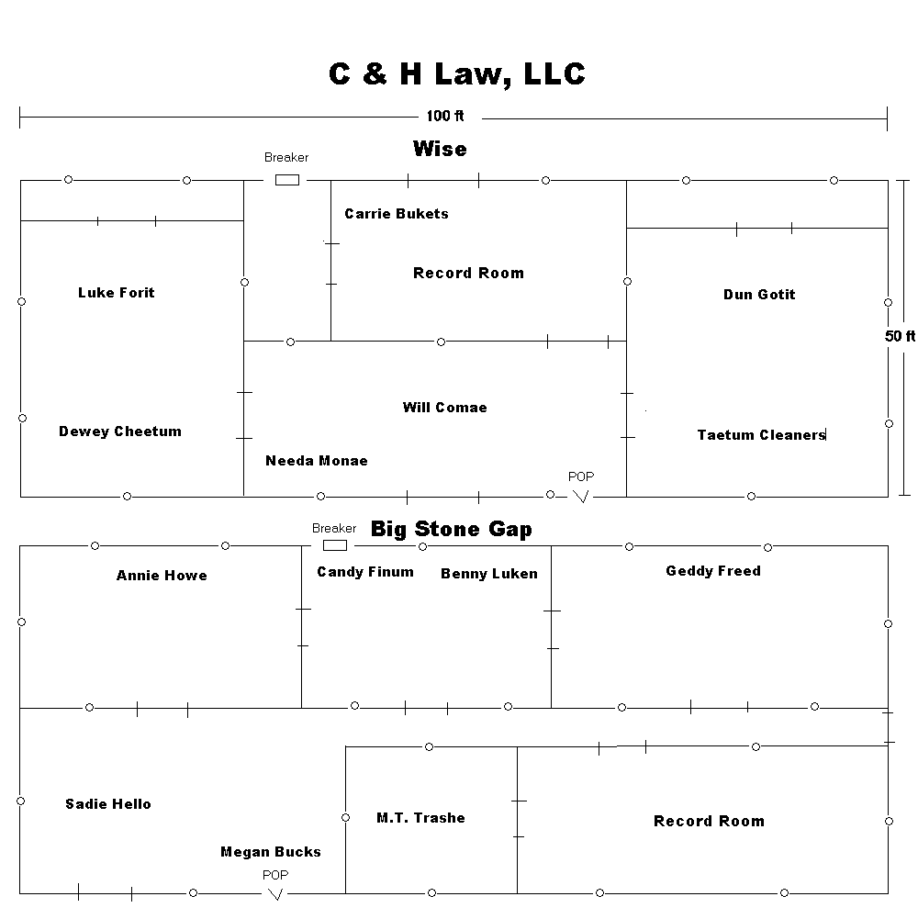
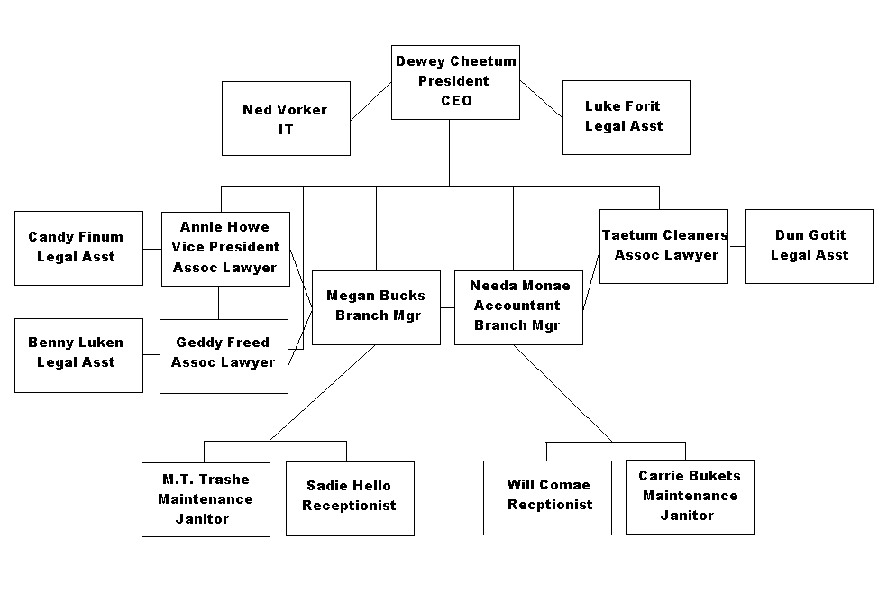
Data Security Requirements

Private
Employee records
Customer records
Contact records
Legal records
Company internals

Public
Services
Lawyer vitae
Testimonials
Contact information

Equipment Owned
4 Dell Personal Computers
2 fax machines
6 phones
14 filing cabinets
2 coping machines

Software Needed
Db Software for data Organization & Cases
Accounting Software
Document Production
Internet Access
E-mail
Calendaring software
Data and Network Access

Dewey Cheetum, Ned Vorker, and Needa Monae – Full access
Megan Bucks, Annie Howe, Taetum Cleaners, Geddy Freed – Read/Write access to Case Database, Read access to Client Database
All Legal Assistants – Read access to Case Database, Legal Reference Material, and Public calendars
Receptionists – Read/Write access to Public calendars, Read/Write access to Client Database

Equipment Present/Needs

Currently have 4 Dell Desktops (P4, 512MB, 10/100 NICs, XP Home) being used by Office managers and Receptionists
Need at least 8 more workstations
Need equipment to provide LAN services to current employees and cover expected growth of 10% per year for the next 5 years
Need equipment to provide WAN services between the two sites, Internet access, and e-mail to employees
Need equipment to provide network printing service to each site

Service Requirements

Our company operates 8AM to 5PM, five days a week and from 10AM to 1PM on Saturdays. We would like to contract IT support for our network which would provide for a total of no more than 2 work days of downtime per month with a back up and working time limit of 6 hours on any network failure. We would also like a full back up of all client, case, and personal data performed weekly with both on-site and off-site storage

